HOME WEEKLY REEFER FLEETS
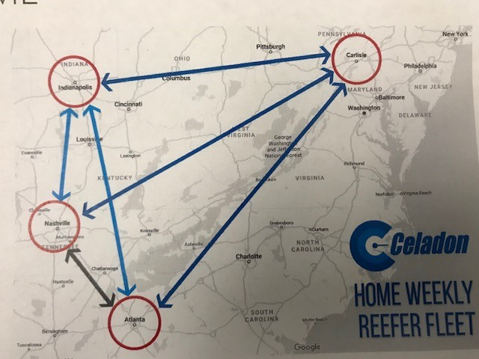

How it works: Celadon has heavy reefer freight volume in these areas. We will run drivers within a dense network with more of an out and back approach. This will allow us to get them home on a weekly basis.
Hiring Area 75-mile radius of:
Indianapolis, IN (IN Reefer Home Weekly) Nashville, TN (TN Reefer Home Weekly)
Atlanta, GA (GA Reefer Home Weekly) Carlisle, PA (PA Reefer Home Weekly)
Running Area: Mostly running in IN, OH, PA, TN, KY, GA, IL. There will be times they will take freight to TX as well.
Pay Package: Standard Celadon Reefer Pay including the additional .03 cpm when under a reefer load, detention, stop and layover pay.
Home Time: Drivers will get home for their 34 hour resets. Please do not say home weekends. If Celadon fails to get a driver home for their reset, Celadon pays the driver $100.
Vacation: Eligible for 30K Vacation Program (1-week paid vacation every 30,000 miles)
Freight Characteristics: Reefer, 40% drop and hook, No Touch Freight
Average Miles Per Week: 2100 - 2500

